**WORKSHEET 1**

**Student Name:** Vivek Kumar **UID:** 21BCS8129

**DOMAIN CAMP:** 16-01-2023 to 28-01-2023 **Section/Group:** DWWC-77

**Subject Name:** IT Skills (DSA)

# Question 1. FIRE & ICE

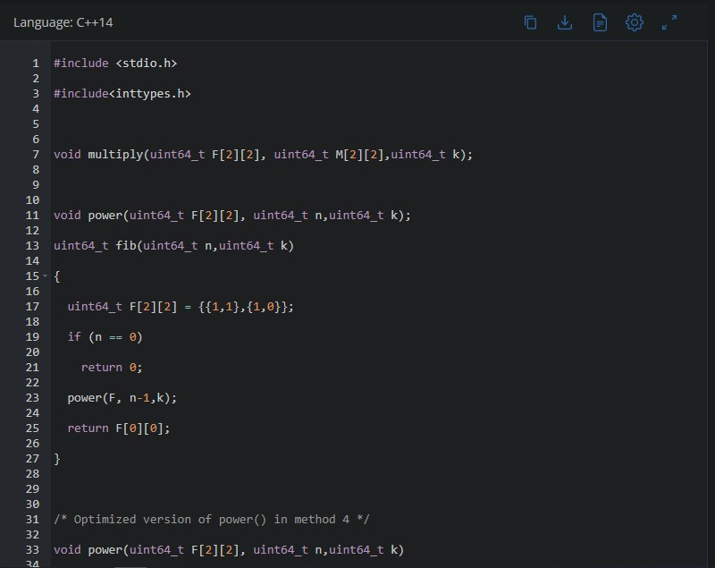

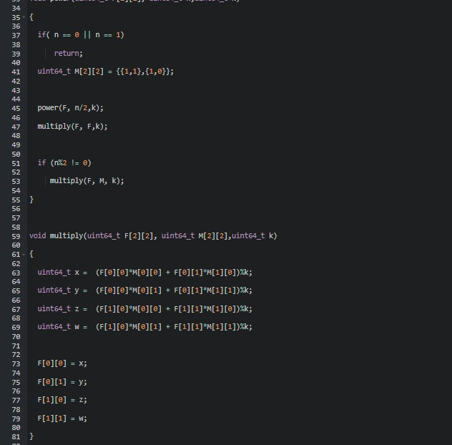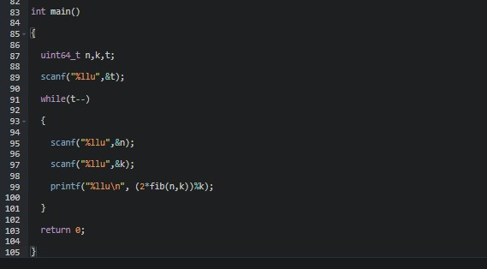

**SOLUTION:**

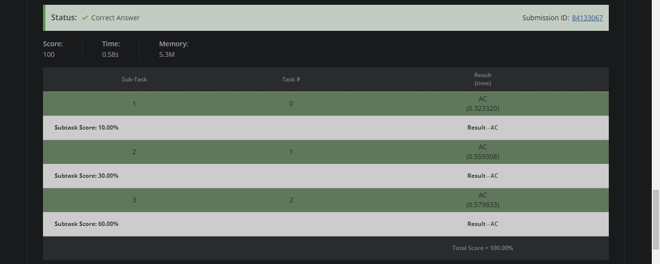

# Question 2. GOLD MINING

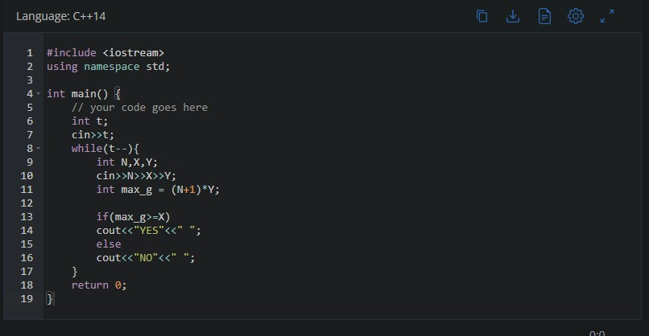

**SOLUTION:**

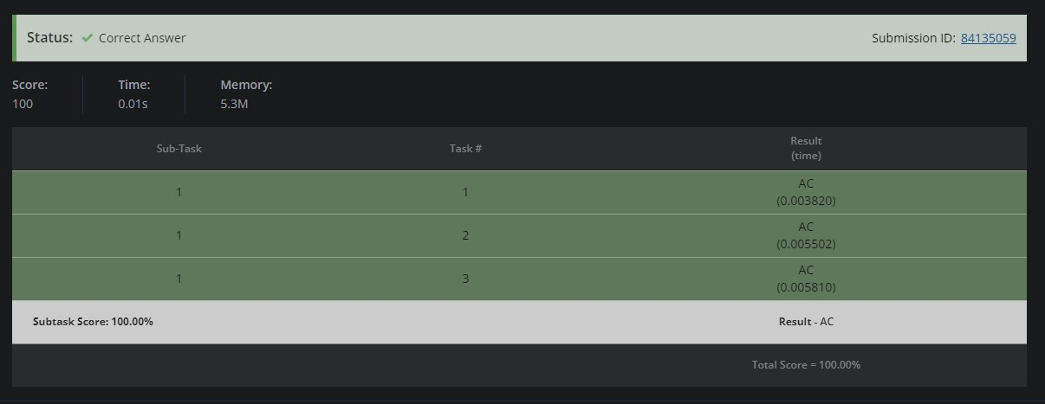

# Question 3. SMALL FCATORIALS

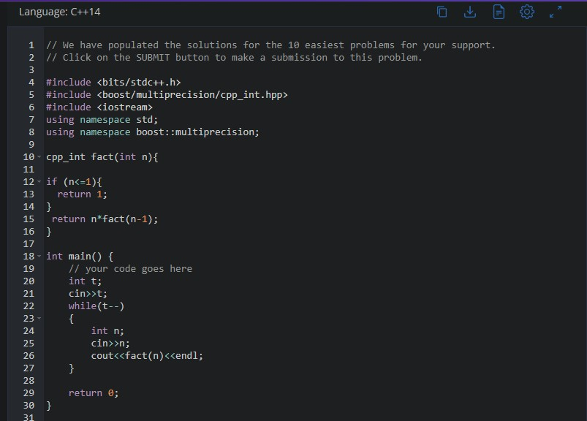

**SOLUTION:**

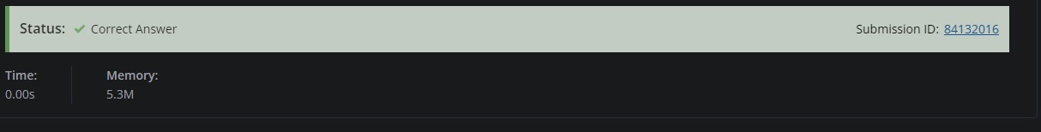

# Question 4. SUM OF DIGITS

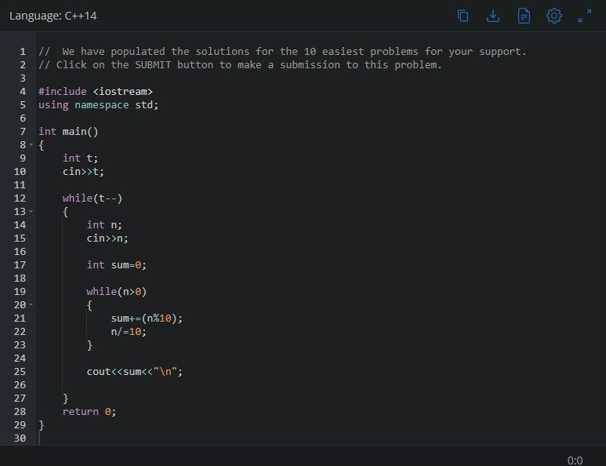

**SOLUTION:**

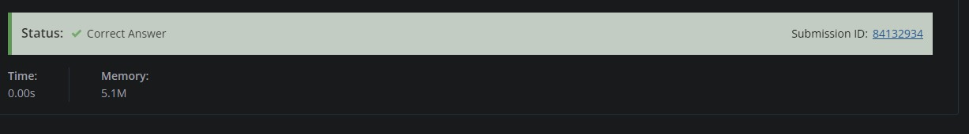

# Question 5. THE LEAD GAME

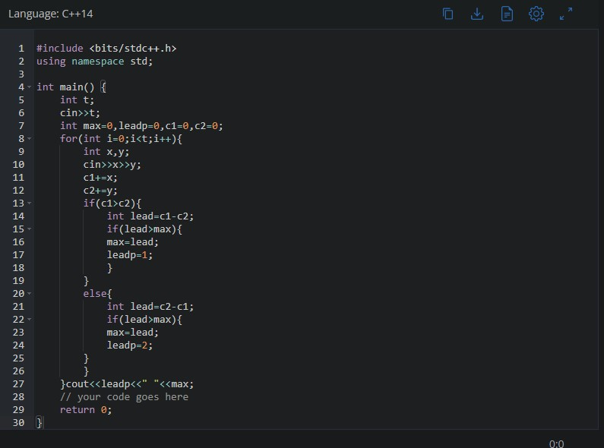

**SOLUTION:**

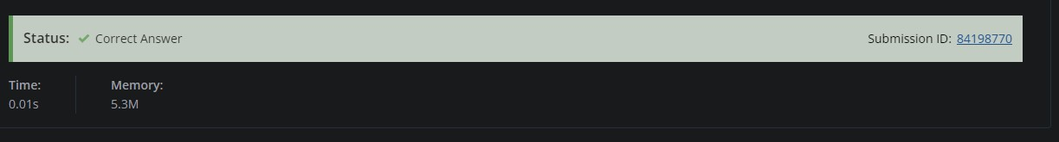

# Question 6. SUMS IN A TRIANGLE

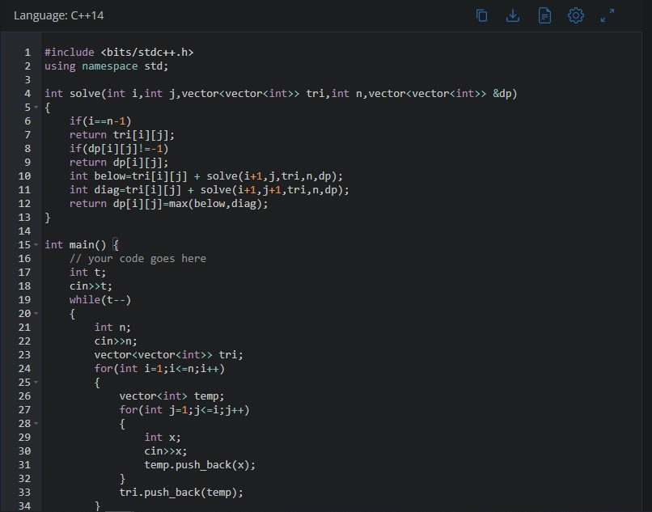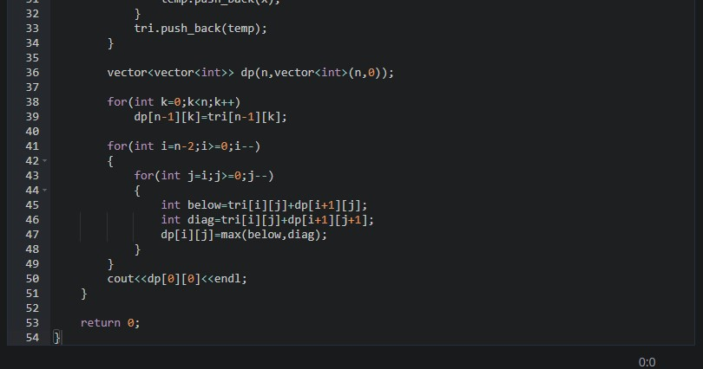

**SOLUTION:**

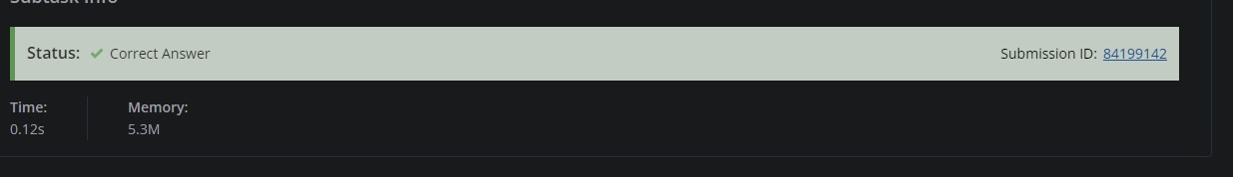

# Question 7. CHEF ON VACATION

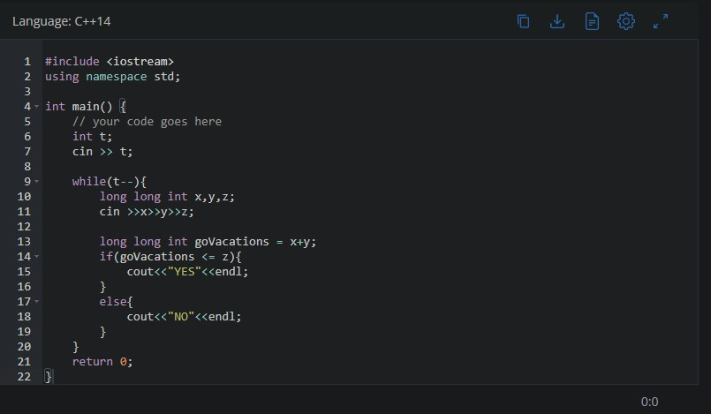

**SOLUTION:**

